EED 1005 INTRODUCTION TO PROGRAMMING

LABORATORY 9, SECTION B

PRELIMINARY ASSINGMENT #9 (TASK 1)

*/\**

*Name: Onurcan KÖKEN*

*Student Number: 2015502053*

*Date: 20.12.2016 13:49*

*Description: EED1005 Preliminary Work #9*

*\*/*

Define an array by using all possible defining methods. Assume that the array’s elements are 17,21,3,0,5.

1. int n[ 5 ] = { 17, 21, 3, 0, 5 };
2. int n[ ] = { 17, 21, 3, 0, 5 };
3. int n[ 5 ];

EED 1005 INTRODUCTION TO PROGRAMMING

LABORATORY 9, SECTION B

PRELIMINARY ASSINGMENT #9 (TASK 2)

*/\**

*Name: Onurcan KÖKEN*

*Student Number: 2015502053*

*Date: 20.12.2016 13:49*

*Description: EED1005 Preliminary Work #9*

*\*/*

Find outputs of the programs given below.

1. #include <stdio.h>

**int** main**()**

**{**

**int** a**[**5**]** **=** **{**5**,** 1**,** 15**,** 20**,** 25**};**

**int** i**,** j**,** m**;**

i **=** **++**a**[**1**];**

j **=** a**[**1**]++;**

m **=** a**[**i**++];**

printf**("%d, %d, %d",** i**,** j**,** m**);**

**return** 0**;**

**}**

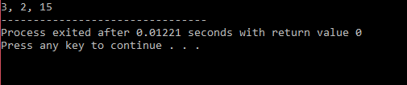

Figure 1: output of the programme

1. #include<stdio.h>

**int** main**()**

**{**

**int** arr**[**5**],** i**=**0**;**

**while(**i**<**5**)**

arr**[**i**]=++**i**;**

**for(**i**=**0**;** i**<**5**;** i**++)**

printf**("%d, ",** arr**[**i**]);**

**return** 0**;**

**}**

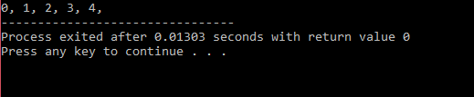

Figure 2: output of the programme